PR SERIES SELECTION AND OPTIMIZATION GUIDE

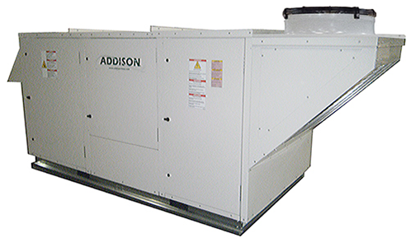

SOLUTIONS TO FREQUENTLY MISSED SELECTIONS
Field # | 1 | 2 | 3 | 4 | 5 | 6 | 7 | 8 | 9 | 10
Field Position & Length | 1-2 | 3 | 4 | 5-6-7 | 8-9 | 10 | 11 | 12 | 13 | 14-15
Field Definition | Product Family | Type | Application | Nominal Capacity | Cabinet Size | Controls | Unit Voltage | Model Vintage | Airflow Orientation | Supply Blower / Size Type
Example | PR | O | A | 240 | C3 | A | 2 | A | A | BG
Field # | 11 | 12 | 13 | 14 | 15 | 16 | 17 | 18 | 19 | 20
Field Position & Length | 16 | 17 | 18 | 19 | 20 | 21 | 22-23 | 24 | 25 | 26-27
Field Definition | Supply Blower Options | Supply Motor Size | Supply Motor Type | Cooling Coil | Compressor Type | Reserve for future use | Refrigeration Controls / Options | Heating Type | Electric Heating Capacity | Gas Heating Capacity
Example | F | E | 1 | B | 5 | 0 | CF | 0 | 0 | 00
Field # | 21 | 22 | 23 | 24 | 25 | 26 | 27 | 28 | 29 | 30
Field Position & Length | 28 | 29 | 30 | 31 | 32 | 33-34 | 35 | 36 | 37 | 38-39
Field Definition | Heater Control | Heating Gas Safety Controls | Energy Recovery | Energy Recovery Options | Ventilation | Exhaust Blower Size | Exhaust Blower Options | Exhaust Motor Size | Exhaust Motor Type | Corrosion Protection
Example | 0 | 0 | F | F | C | 00 | T | D | 1 | 00
Field # | 31 | 32 | 33 | 34 | 35 | 36 | 37 | 38
Field Position & Length | 40-41 | 42-43 | 44-45 | 46-47 | 48 | 49 | 50-51 | 52-53
Field Definition | Maintenance Options | Power Options | Control Options | Safety Controls | Pre-Filter | Reserve for Future Use | ALC Ship With Options | PR ROOF CURBS
Example | 00 | 00 | 00 | 00 | 0 | 0 | BK | CC

Airflow Orientation &Ventilation
- These options are dependent upon the unit application and PR Controls selected. Use the tables in the Controls Guidelines section to ensure what is compatible.

Refrigeration Controls/Options
- These options are dependent upon the compressor type selected. Refer to the Refrigeration Controls Guideline section to ensure the correct components are selected with the desired application.

Supply Blower Options & Supply Blower Type
- The ACE Selection Software tool auto selects the fan based on the data entered, and this needs to be verified in order to make sure the fans do not conflict.
- If the ACE Selection Software selects an ECM Fan, then ONLY select from the ECM options.
- ANPL and ANPA fans are Comefri, and this fan is compatible ONLY with options labeled with “Comefri”
- Refer to the PR Cabinet Rules section to verify which fans are compatible with which unit.

Exhaust Blower Options and Exhaust Motor Type
- The ACE Selection Software tool auto selects the fan based on the data entered, and this needs to be verified in order to make sure the fans do not conflict.
- If the ACE Selection Software selects an ECM Fan, then ONLY select from the ECM options.
- ANPL and ANPA fans are Comefri, and this fan is compatible ONLY with options labeled with “Comefri”
- Ensure that options with no exhaust air flow do not select any options regarding exhaust fans. This will cause a conflict in the software.
- As of right now, 25” fans select with 3 HP, however the lowest available is 5 HP. If this occurs contact the apps department.
- Refer to the PR Cabinet Rules section to verify which fans are compatible with which unit

PR CABINET RULES
Use the following matrix to determine which PR Components are compatible.
PR Rules
Cabinet | MAX Blower | MAX ECW | Max Heating Capacity | Max Furnace XL Cabinet
A Cabinet  450-2500 CFM | GHKM400  355,315,280  (ECM Motors ONLY) | ECW364  244,324 | 100 MBH  (30 KW) | N/A
B Cabinet  2000-4000 CFM | GHKM450  450,355 | ECW424  244,324,  364 | 200 MBH  (100 KW) | (2)200 MBH
ANPL16
10,11,12,14,16
C Cabinet  3000-7000 CFM | GHKM450  ANPL20  14,16,18 | ECW486  324,364,  424,484 | 300 MBH  (100 KW) | (2)400 MBH
D Cabinet | 2-GHKM450  2-355, 450, | ECW706  484,486, | 400 MBH  (150 KW) | (2)600 MBH
6000-11000 CFM | ANPL25 | 544,606,  664,666
 | 22,20,18
E Cabinet  8000-20000 CFM | (2) ANPL20  (1) ANPL25 | ECW8412 | 600 MBH  (150 KW) | Vertical Supply  (4)400 MBH
 |  |  | (No horizontal supply available) | Horizontal Supply  (2)600

Furnace Options
Furnace MBH Input | Furnace MBH Output | Heaters | Stages | Modulation
75 | 60 | (1) 75 | 2 | 5:1
100 | 80 | (1)100 | 2 | 5:1,10:1
150 | 120 | (1)150 | 2 | 5:1,10:1
200 | 160 | (1)200 | 2 | 5:1,10:1
250 | 200 | (1)250 | 2 | 5:1,10:1
300 | 240 | (1)300 | 2 | 5:1,10:1
350 | 280 | (1)350 | 2 | 5:1,10:1
400 | 320 | (1)400 | 2 | 5:1,10:1
500 | 400 | (1)500 | 2 | 5:1,10:1
600 | 480 | (1)600 | 2 | 5:1,10:1
200 | 160 | (2)100 | 4 | 10:1
300 | 240 | (2)150 | 4 | 10:1
400 | 320 | (2)200 | 4 | 10:1
500 | 400 | (2)250 | 4 | 10:1
600 | 480 | (2)300 | 4 | 10:1
700 | 560 | (2)350 | 4 | 10:1
800 | 640 | (2)400 | 4 | 10:1
1000 | 800 | (2)500 | 4 | 10:1
1200 | 960 | (2)600 | 4 | 10:1
800 | 640 | (4)200 | 8 | 20:1
1000 | 800 | (4)250 | 8 | 20:1
1200 | 960 | (4)300 | 8 | 20:1
1400 | 1120 | (4)350 | 8 | 20:1
1600 | 1280 | (4)400 | 8 | 20:1

OPTIMIZING PR CABINET SELECTIONS
Use the following matrix for determining an optimal PR Cabinet when price is a concern.
PR Cabinet Selection Guide
Cabinet | CFM Range | Gas Heater Max Size | When to use XL | Notes
A Cabinet | 450-3,300  Horizontal SA 3,300 Max  Horizontal RA 2,700 Max | 100 MBH | NA | ECM supply fans ONLY.  If you need ODP or TEFC use B Cabinet.  On a PRRA, will require 6 row coil for DOE.
B Cabinet | 2,500-5,200  Horizontal SA 5,200 Max  Horizontal RA 3,300 Max | 200 MBH  400 MBH (XL) | When you need between  350-400 MBH | If you need 250-300 MBH use the C cabinet. (Price will be lower always)
C Cabinet | 3,000-6,200  Horizontal SA 6,200 Max  Horizontal RA 3,000 Max | 300 MBH  800 MBH (XL) | 350-800 MBH | You might not be able to run ECW above 5,000 CFM in Ace. If this occurs send to apps.
D Cabinet | 6,000-11,000  Horizontal SA 9,500 Max  Horizontal RA 5,500 Max | 400 MBH  1,200 MBH (XL) | 400 MBH-1,200 MBH  Some Heat Pumps | D Cabinet is going to be a better price than E 99% of the time.  Use Sub-cooling and always check 4 row coil performance compared to 6 row coils.
E Cabinet | 8,000-20,000  Horizontal SA 16,000 Max (XL ONLY)  NO Horizontal RA (E AND EXL) | 600 MBH  1,600 MBH XL (Vertical)  1,200 MBH XL (Horizontal) | Required for some  Tandem compressors  OR over 600 MBH | Check 4 row coil performance  to ensure price savings for minimal performance drop.

Cabinets
- Smaller cabinet size will ALWAYS result in a better price. C is cheaper than BXL, CXL is cheaper than D, etc...
When to go to EXL
- Only go to EXL when furnace size requires it.

REFRIGERATION CONTROLS GUIDELINES
Use the following table to ensure the correct PR selections are made.
PR Series Refrigeration Controls Application Based on Compressor Selection
Compressor Type | How to Implement  HGRH | How to Implement  HGBP | Notes | How to Implement  Liquid Subcooling
Standard Scroll/Single Circuit | ONLY Single Circuit.  Staged OR Modulating. | REQUIRED for 100% OA applications.  Recommended for RA and MA applications. | Units 96 MBH and BELOW  Standard Scroll MUST select Single Circuit. | DO NOT select with Dual Circuit HGRH.  Select with Single Circuit HGRH OR alone.  DO NOT select with Heat Pump applications ABOVE 360 MBH.
Dual Scroll/  Dual Circuit | Select Dual Circuit OR  Single Circuit  Staged OR Modulating. | Select Dual Circuit ONLY | Units 120 MBH and ABOVE
Digital Scroll/Single Circuit | Single Circuit ONLY.  Staged OR Modulating. | No HGBP with Digital Scrolls. | Heat Pump and Water Source units MUST use Digital Scroll(s).  Units 96 MBH and BELOW
Single Digital and Single Scroll/Dual Circuit | Select Dual Circuit OR  Single Circuit  Staged OR Modulating. | Lag Circuit ONLY.(Optional) | Digital Scroll ALWAYS on lead circuit.  Units 120 MBH and ABOVE
Dual Digital Scroll/  Dual Digital Circuit | Select Dual Circuit OR  Single Circuit  Staged OR Modulating. | No HGBP with Digital Scrolls. | Units 120 MBH and ABOVE

Price Optimizing Measures
Compressors
- Digital ALWAYS more expensive than regular scroll compressors.
Liquid Subcooling
- Recommended as a method to improve upon cost and provide more efficiency for 100% OA Units.
- No Liquid Subcooling is available for Heat Pump applications ABOVE 360 MBH. The receiver for this application is too big and it cannot be implemented for that purpose.
4 row coils vs. 6 row coils (Especially when deciding between the E and D cabinet).
- 4 row coils will ALWAYS result in a lower price, however compare with 6 row coils to ensure performance drop is minimal/acceptable.
ACE Selection Notes for Refrigeration Controls
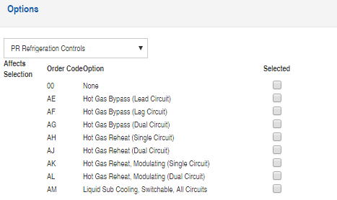
Required when regular scroll compressor are used for 100% OA systems.
Staged HGRH
Only with single circuit HGRH

CONTROLS GUIDELINES
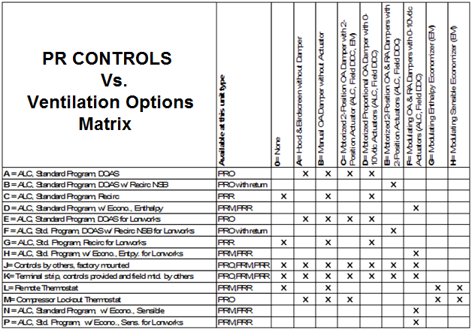

Economizer for 100% OA units: It is included in the standard SOO. Refrigeration system will turn off and only fans will work to introduce 100% OA when conditions are cold and dry enough.

PR Controls  Vs.  Airflow Orientation | A = Vertical Supply and Vertical Return | B = Horizontal Supply and Vertical Return | C = Vertical Supply and Side Return | D = Horizontal Supply and Side Return | E = Vertical Supply and No Return | F = Horizontal Supply and No Return
A = ALC, Standard Program, DOAS
B = ALC, Standard Program, DOAS w/ Recirc NSB
C = ALC, Standard Program, Recirc
D = ALC, Standard Program, w/ Econo., Enthalpy
E = ALC, Standard Program, DOAS for Lonworks
F = ALC, Std. Program, DOAS w/ Recirc NSB for Lonworks
G = ALC, Std. Program, Recirc for Lonworks
H = ALC, Std. Program, w/ Econo., Entpy. for Lonworks
J= Controls by others, factory mounted
K= Terminal strip, controls provided and field mtd. by others
L= Remote Thermostat
M= Compressor Lockout Thermostat
N = ALC, Standard Program, w/ Econo., Sensible
P = ALC, Std. Program, w/ Econo., Sens. for Lonworks

